Heart Rate Variability Biofeedback Treatment for Post-Stroke Depression Patients: A Pilot Study
Xin Li¹, Tong Zhang¹, Luping Song¹, Guigang Zhang², Chunxiao Xing²
¹School of Rehabilitation Medicine, Capital Medical University, Bejing, China
Department of Comprehensive Rehabilitation, China Rehabilitation Research Center
² Research Institute of Information Technology,
Tsinghua National Laboratory for Information Science and Technology,
Department of Computer Science and Technology, Tsinghua University, Beijing, China
horsebackdancing@sina.com, zt61611@sohu.com, songluping882002@aliyun.com,zhangguigang@163.com,
xingcx@tsinghua.edu.cn
Abstract.Treatment for post-stroke depression (PSD) is a very complicated system engineering, and it need quite a long time to see the effect. In this paper, through clinical trials, we adopt the method of heart rate variability biofeedback treatment for PSD patients. Through analysis of clinical trials, we hope to improve the situation of emotion on patients, the autonomic nervous function and reduce the impact by the prognosis of heart rate variability biofeedback, with dynamic observation of indices of variation on heart rate variability biofeedback under pressure/non-pressure, and summary of training scheme for PSD patients. In our research, by activating and enhancing the Baroreceptor Reflex function, it can improve the HRV indices and make mood better. We focused on heart rate variability biofeedback influence on depression and anxiety in clinical trials of its impact and corresponding experimental results is obtained.
Keywords: Heart Rate Variability, Biofeedback, Stroke, Depression
1 Introduction
The post-stroke depression(PSD)^{[1][2]} is a common complication of cerebral vascular disease, it refers to varying degrees of depression after cerebral apoplexy and symptoms persist for more than 2 weeks, often characterized by depression, slow thinking, anxiety, despair, irritability, sleep disorders, low self-assessment, lack of initiative and body fatigue and other symptoms. At present, most of PSD is diagnosed by symptoms and psychological assessment scale such as self-expression, which is lack of objectivity in diagnosis and evaluation of the quantitative basis. In recent years, heart rate variability (HRV)^{[3][4]} research method has been greatly improved and extended. HRV is pulsing rhythm of heart rate that occurs over the changing time, with easy operation and testing of non-invasive, sensitive, intuitive and quantitative advantages. HRV is mainly influenced by sympathetic nerve and vagus nerve activity, and also the relative balance, reflecting the mutual restriction relations of autonomic nervous system activity and the cardiovascular system, therefore HRV may be considered to a convenient window for understanding the human body state of the autonomic nervous system function, which is the quantitative indicators of judgments, explanations and prediction on the autonomic nervous system activity. HRV has become the hotspot research frontier in the field of ECG (electrocardiogram) signal processing and methods.
Currently most of the clinical treatment of PSD with drug therapy and cognitive-behavioral therapy, although drug treatments have been affirmed by the clinical, it will not only improve the quality of life in patients with stroke, but also contribute to nerve function rehabilitation after stroke ^{[5]}. But there are still some patients treated with drugs that won't work, and some patients that relapse after discontinuation, in rare cases it is difficult to withstand adverse drug reactions. Cognitive behavioral therapy for depression in patients with psychotherapy, the focus should be on faith, changes in perception, thinking, thought, by correcting the irrational belief to change behavior，the goal of treatment is to establish new appropriate behavior. Cognitive-behavioral therapy aims to help patients recognize their own thinking and action on the negative attitudes, learn to control your emotions, to adapt to the environment, by correcting a patient's basic concept of preventing recurrence of depression. However, levels of HRV^{[6-10]} in PSD patients is low, while sensitivity to stress and disease is improved, and PSD patients are difficult to adapt to the stress, chronically high levels of stress and more likely to suffer from cardiovascular disease, whose stroke recurrence rates are high. These patients tend to be poor psychological reaction of cognitive-behavioral therapy, medication and drug problems such as slow onset and a variety of side effects, so it is imminent to look for a more economical, simple and convenient needle for PSD patients, with no adverse effects of intervention.
Biofeedback therapy is a behavior treatment method of no trauma and almost no side effects, and with the help of the instruments it could enlarge the extremely weak physiological activity that can’t be usually aware of and electrical activity of information inside the body, to become visible waveform and audible voice displayed out in instrument. Then individuals with visual, and hearing organ through feedback information can understanding their changes, and according to changes gradually in some degree learn to control and correct these activities of process. After training, the adjustment function eventually becomes a self-regulating mechanism, which is formed and maintained without the feedback instrument to control and adjust some of the psychological and physiological reaction skills. Through relaxation training, biofeedback reduces the level of muscle tension to eliminate patients with depression, anxiety and tension, enhance vagus nerve function, and reduce sympathetic tone, so as to achieve the goal of treatment. Biofeedback therapy is different from conventional drug therapy, and throughout the course of therapy patients are the active participants showing high enthusiasm combined with therapy, which making the curative effect is better.
HRV biofeedback ^{[11-17]} is a newly developed method of biofeedback therapy, which is used to treat those disease related with HRV decrease. Many experiments have found that HRV biofeedback can improve HRV indices and/or baroreceptor reflex function, thus affecting the clinical symptoms and prognosis.
2 Experiment Conditions Selection
In order to improve the accuracy of the research, in this paper, the experimental requirements on patient selection imposes certain conditions, mainly includes: the selected condition and the exclusions condition.
2.1 Selected patients with the following conditions
- Ages 18 to 75, men and women not limited;
- Meet the diagnostic criteria of stroke according to the fourth national cerebrovascular disease academic conference in 1995, and the cranial CT or MRI confirmed, and accompanied by limb movement disorder at the first attack of stroke patients;
- Meet the international classification of diseases coding (ICD-10) depression, without diagnostic criteria of psychotic symptoms, with or without anxiety, and the Hamilton depression rating scale (HAMD)-24, scores more than 20 points;
- In the pathogenesis of stroke within 2 to 6 months after the test, the vital signs are stable;
- Patients conscious, directional force intact, no significant disorder of memory, understanding and intelligence;
- Primary school culture degree above;
- To complete the testing and treatment, and signed informed consent.
2.2 Exclusion standard includes the following conditions
- Depressive state, with psychotic symptoms;
- Prior history of psychiatric disorders and mood disorders;
- With serious pulmonary infection, central respiratory failure, electrolyte disorder, high fever disease that affects the heart activity;
- With other organic diseases, history of arrhythmia (atrial fibrillation, frequent premature ventricular), hyperthyroidism, history of syncope and autonomic dysfunction, detection of drugs affecting the autonomic nervous system activity and substance;
- Serious disturbance of consciousness, dementia and cognitive impairment and aphasia;
- The brain stem infarction;
- Severe dysarthria and swallowing disorders;
- Recent home suddenly appeared accident or bad life stress incident (such as widowed, childless, laid-off etc.);
- Fails to cooperate, not to follow treatment scheme, and patients after the Group 5 training Essentials still unable to master the essentials of breathing should be excluded.
3 Experiment Method
This experiment is the prospective randomized controlled research on the heart rate variability biofeedback treatment for PSD patients, it aims to understand the heart rate variability biofeedback emotional improvement in stroke patients, the autonomic nervous function and the influence of prognosis, with dynamic observation of indices of variation on heart rate variability biofeedback under pressure/non-pressure, and summary of training scheme for PSD patients.
This experiment provide a scientific experimental basis for the clinical application of HRV biofeedback therapy on PSD and evaluation on its efficacy, and also the application of objective methods for the future diagnosis and treatment of emotional and cognitive impairment after cerebral stroke and merged diseases related with HRV decrease, and improve their balance of autonomic nervous function, strengthen the baroreceptor reflex function and set up the experimental and theoretical basis. As a new treatment, HRV biofeedback has simple, safe and convenient operation, for clinical practice and accumulated valuable experience, become a useful supplement comprehensive rehabilitation.
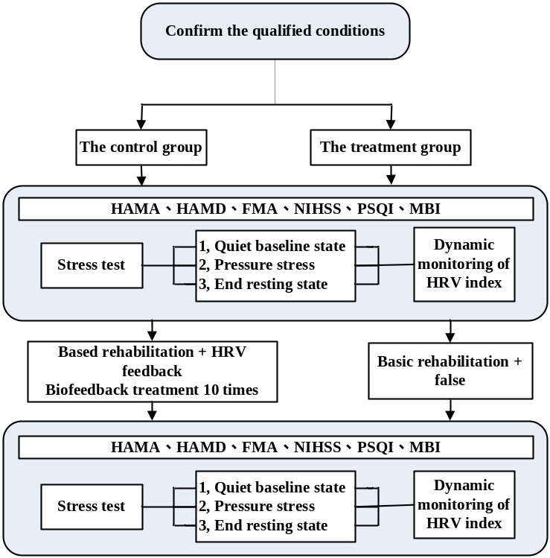
Figure 1. Experiment Framework
With the development of the society, an aging society has arrived. Cerebrovascular disease, as a disease of the elderly, the incidence and morbidity in our country especially is higher than other diseases. The study opens up a new, scientific and effective method for the treatment of DSP, and in the domestic for a breakthrough, which will have significant improvement on relieving pain for patients at the same time and bring huge economic benefits and social benefits.
Figure1 shows the experiment framework which is our design process.
4 Experiment Results
We focused on heart rate variability biofeedback influence on depression and anxiety in clinical trials of its impact. Our experiment found that both the depressive symptoms and the anxiety symptoms were obviously improved.
4.1 The influence of heart rate variability biofeedback for depression
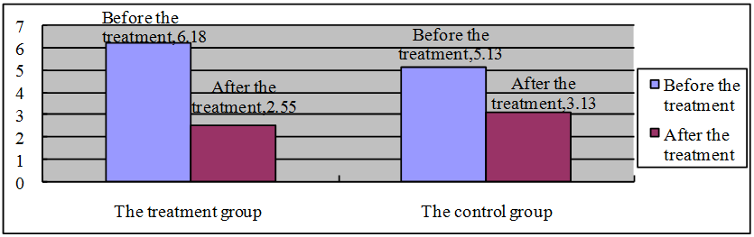
Figure 2. HAMD anxiety somatization factor comparison between the two groups
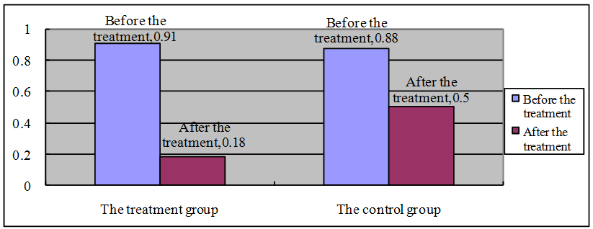
Figure 3. HAMD weight factor comparison between the two group
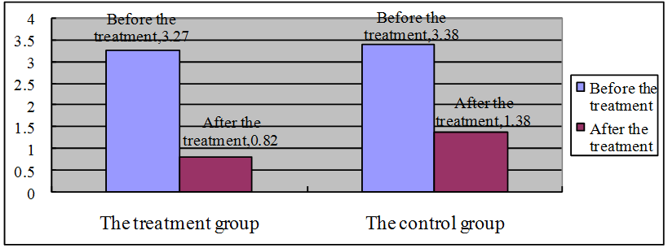
Figure 4. HAMD cognitive factor comparison between the two groups
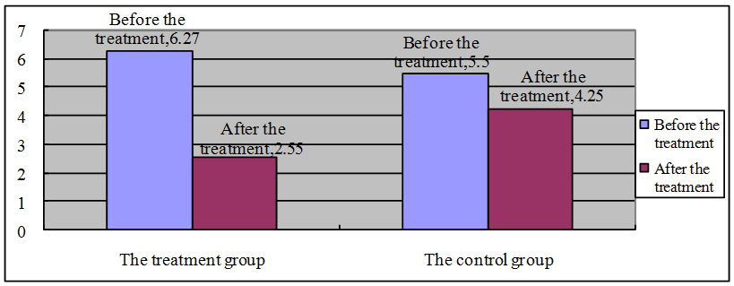
Figure 5. HAMD block factor comparison between the two groups
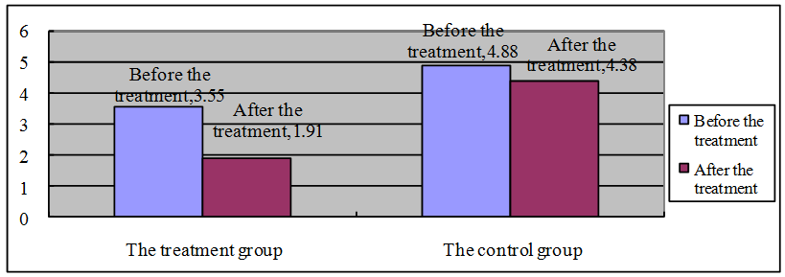
Figure 6. HAMD sleep disorders factor comparison between the two groups
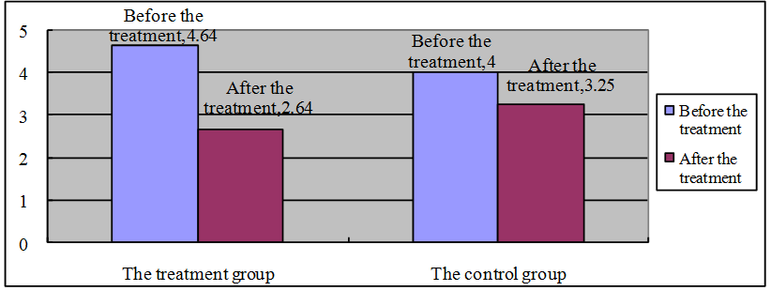
Figure 7. HAMD despair factor comparison between the two groups
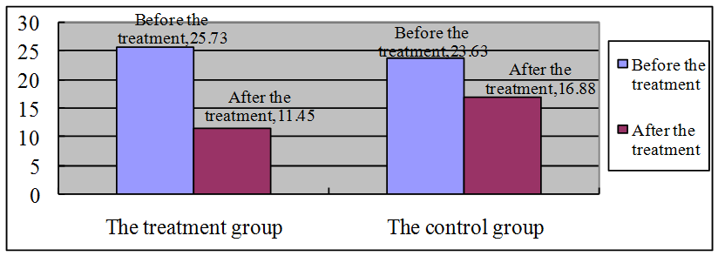
Figure 8. HAMD depression scores comparison between the two groups
4.2 Experimental results of heart rate variability biofeedback for anxiety
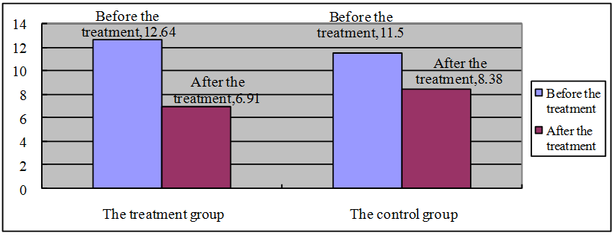
Figure 9. HAMA spirit factor comparison between the two groups
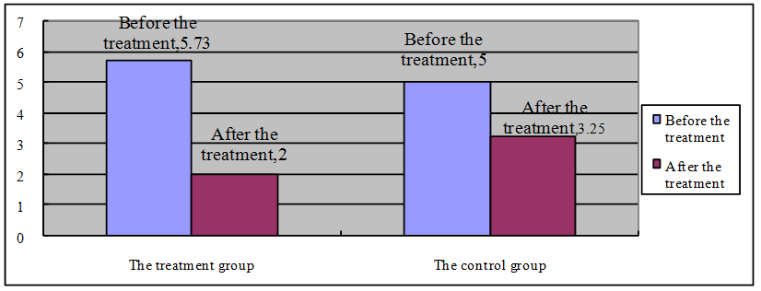
Figure 10. HAMA body factor comparison between the two groups
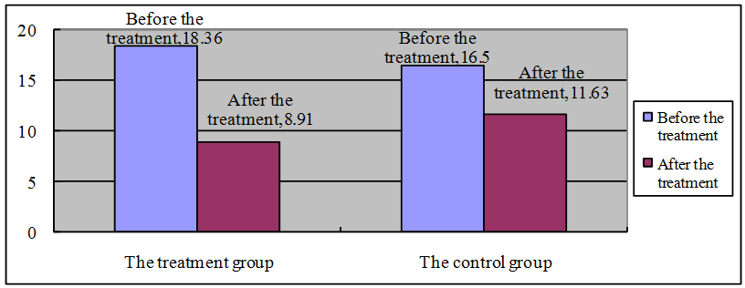
Figure 11. HAMA anxiety scores comparison between the two groups
5 Discussion
This study reveals that 10 times HRV biofeedback is an effective treatment for post-stroke depression patients with no side effects caused by the intervention of antidepressant drugs. According to the HRV data collected in our experiment, all patients who completed the training have mastered the method of carrying out HRV biofeedback, and can take the initiative to apply this breathing method to daily life. Results showed significant differences between the group taking HRV biofeedback treatment and the group breathing at resonance frequency (5.5 to 6 times per minute). Mechanism for the change of HRV is unclear at present. After lots of authoritative research, Lehrer thought that the increase of HRV was caused by stimulation of baroreflex. And the baroreflex also plays an important role in achieving homeostatic state of autonomic function and the adaptability of entire cardiovascular system. Only when patients breathe at resonance frequency, baroreflex will be activated to the greatest extent. By behavioral therapy, patients strengthen the control of self-regulation on autonomic nervous function, which indicates the improvement of functional activity of vagus nerve.
Our experiment found that although the clinical symptoms, both the depressive symptoms were obviously decreased, unlike the Karavidas^{[3]} results in significant improvement. I think the disease specificity of post-stroke depression disease may account for this. Most scholars favor the theory of "biological mechanism", which believes that the parts of the brain damaged and neurotransmitters are important factors in determining whether stroke patients suffer from depression. Although the observed indicators of the study did not involve the measure of various neurotransmitter and hormone levels, previous studies have showed that the depression combined stroke has a greater impact on HRV than mere stroke or simply depression, and its damage on autonomic nerve is more serious. Based on the above results, our experiment found that after 10 times HRV biofeedback, depression levels of patients were still in the recovery process, but they were not completely cured. There exists a need to increase the frequency and intensity of training to observe its long-term effect. The recovery mechanism of HRV biofeedback therapy for stroke patients with depression needs to be further studied.
6. Conclusion
In this paper, through clinical trials, we adopt the method of heart rate variability biofeedback treatment for PSD patients. We focused on heart rate variability biofeedback influence on depression and anxiety in clinical trials of its impact. We applied Heart Rate Variability (HRV) biofeedback to train PSD patients by a prospective randomized control study. This study reveals effectiveness of the HRV biofeedback on stroke patients’ emotional improvement, autonomic nerve function and prognostic implications. HRV biofeedback is a beneficial adjuvant treatment for patients with post-stroke depression in rehabilitation training. Our findings suggest that 10 times HRV biofeedback is an effective treatment for post-stroke depression patients, especially on the improvement of depression levels and sleep disturbance.
In the future, we’ll extend the follow-up time, add observed indicators of prognosis, and clarify their level of efficacy. Meantime, we will continue to deepen the HRV biofeedback and changes of individual psychological and physiological indexes in the treatment of pressure under stress, can also study HRV biofeedback index change on the level of consciousness, arousal, attention and other higher cognitive functions. There is no significant difference between the two groups. It is generally believed that depressed patients have memory and learning neural psychological defects, early research suggests depression in patients with nerve psychological defects could be secondary to depression, but recent studies have shown that psychological depression in patients with nerve defects can't explain completely by depression and other psychological factors. After treating depression improves, neuro-psychological defects still exist inside the patients. The next step could be a detailed observation of cognitive-related indicators. Correctly to handle the pressure stress, emotional stability, ease pain, improve sleep, enhance attention adaptability, and learning ability, which has important clinical significance for the prognosis of patients with cerebral stroke rehabilitation.

Acknowledgements. This study was supported by the National Basic Research Program of China (973 Program) No.2011CB302302. We would like to thank Dechun Sang, Songhuai Liu, Lin Wang, Shufeng Ji, from Bo Ai Hospital, Beijing. We also appreciate the research assistance provided by Yan Zhang MSc from Tsinghua University.
References
- Yang Ming-ming: Relationship among Depression, Anxiety and Possible Factors in Post-stroke Patients: 510 Cases Report. Chinese Journal of Rehabilitation Theory and Practice. 12(6), 498-500 (2006)
- Xiang Dai-qun, Yang Rong, Li Rong-mei, et al.: Analysis of Post-stroke Anxiety Disorders and the Related Factors. Huaxi Medicine, 19(1), 133 (2004)
- Karavidas, M. K., Lehrer, P. M., Vaschillo, E. G., Vaschillo, B., Humberton, M., Buyske, S., et al.: Preliminary results of an open label study of heart rate variability biofeedback for the treatment of major depression. Applied Psychophysiology and Biofeedback, 32, 19-30 (2007)
- Zucker, T. L., Samuelson, K. W., Muench, F., Greenberg, M. A., & Gevirtz, R. N.: The effects of respiratory sinus arrhythmia biofeedback on heart rate variability and posttraumatic stress disorder symptoms, A pilot study. Applied Psychophysiology & Biofeedback, 34, 135-143 (2009)
- National Conference on Cerebrovascular Disease Score Standards in Clinical Neurological Deficit for Stroke Patients (1995). Chinese Journal of Neurology, 29(6), 381-383 (1996)
- Lehrer，P. M. Applied psychophysiology：Beyond the boundaries of biofeedback (mending a wall，a brief history of our field，and applications to control of the muscles and cardiorespiratory systems). Applied Psychophysiology and Biofeedback，2003，28(4)：291~304
- Kleiger R.E.，Miller J.P.，Bigger J.T.，et a1．Decreased heart rate Variability and its association with increased mortality after acute myocardial infarction．Am J Cardiol，1987，59：256~262
- Carod Artal F. J. ，Gonzalez Gutierrez J.L. ，Egido Herrero J. A. ，et al. Post stroke depression :predictive factors at one year follow up. Rev Neurol，2002，16~31
- Hayee M. A. ，Akhtar N. ，Haque A. ，et al. Depression after stroke2analysis of 297 stroke patients. Bangladesh Med Res Counc Bull，2001，27 (3)：96~102
- Nolan，R. P.，Kamath，M. V.，Floras，J. S.，& Stanley，J. Heart rate variability biofeedback as a behavioral neurocardiac intervention to enhance vagal heart control. American Heart Journal，2005，149(6)：1137
- Dishman RK，Nakamura Y，Garcia ME，et a1．Heart rate variability，trait anxiety，an d perceived stress among physically fitmenand women．Int J Psychophysiol，2000，37(2)：121~133
- MonkC，KovelenkoP，E1lmanLM，et a1．Enhanced stress reactivity in paediatric anxiety disorders，implications for future cardiovascular health．Int J Neumpsychopharmacol，2001，4(2)：199~206
- Slosh RP，Shapiro PA，Bagiella E+ et o1．Temporal stability of heart period variability during a resting baseline and in response to psychological challenge．Psyehophysiology 1995，32(2)：191~6
- Hayanao J，Sakakibaba Y，Yamada A，et al. Accuracy of assessmena of cardiac vagal tone by heart rate variability in normal subjects. Am J cardiol，1991，67：199~204
- Hedman AE，Hartikainen JEK，Tahvanainen KUO，et al. The high frequency component of hear rate variability reflects cardiac parasympathetic modulatin rather than parasympathetic 'tone'. Acta Physiol Scand，1995，155：267~273
- Salahuddin L，Cho J，Jeong MG，et a1．Ultra short term analysis of heart rate variability for monitoring mental stress in mobile settings[A]．In：Proceedings of the 29th Annual International Conference of the IEEE[C]．Lyon：IEEE EMBS，2007．4656~4659
- David ww． Physiological correlates of heart rate variability (HRV)and the subjective assessment of workload and fatigue in-flight crew：a practical study[A]．In：People in Contro1．An International ConfeFence on Human Interfaces in Control Rooms [C]．Manchester：Cockpits and Command Centers，2001．159~163

